Workshop Exercise
You are part of a multi-disciplinary team drawing together proposals for a residential-led mixed use development (the New Brunstane Residential Development) on this site. Please take 15 minutes as a group to review the information and drawings below and consider the following questions.
- What do you consider are the main issues affecting this site?

- Where would you go to find information on these?

- What do you consider are the main opportunities for developing this site?

- Which Key Agencies would you approach for advice relating to the issues and opportunities you have identified above?

- At what stage would you choose to engage the Key Agencies you have identified?

- What role would you expect the Local Authority Case Officer to play in assessing the proposals?

Development Proposals

The site is located within the urban area to the south-east of Edinburgh, in the City of Edinburgh Council (CEC) area. The eastern edge of the site is on the boundary with the East Lothian Council (ELC) Area. The total area of the site enclosed by the planning redline boundary is 54.6 hectares. The proposals are for a residential-led mixed use development.
The site is allocated within the adopted City of Edinburgh Local Development Plan (2016) for housing-led development with a notional capacity of 950 to 1,330 units.
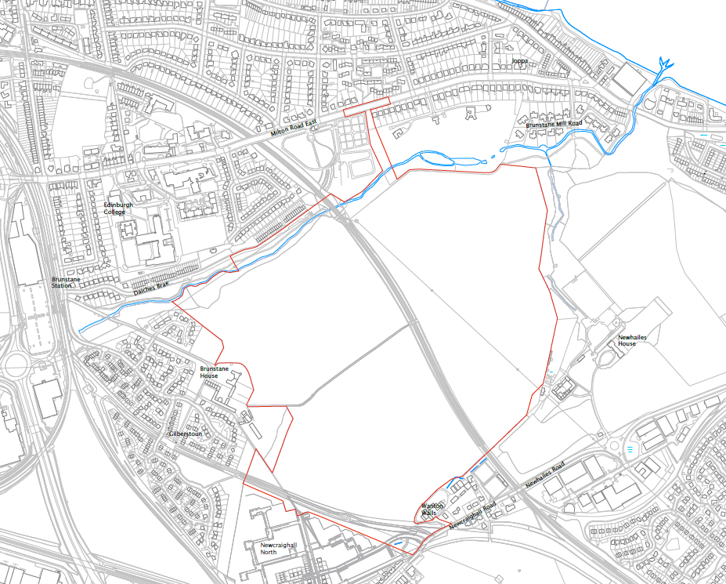

Development Site
The eastern edge of the site is bordered by the designed landscape of Newhailes House and mature woodland, marked by a brick wall and enclosing grounds. The Brunstane Burn defines the northern edge of the site, and its northern bank is populated by housing at Daiches Braes, Edinburgh College: Milton Road Campus, the Milton Road Cemetery and Milton Glen Golf Course.
The John Muir Way footpath runs parallel to the Brunstane Burn, crossing the south bank of the East Coast Main Line (ECML) railway line and adjoining the northern edge of the eastern field. National Cycle Route 1 (NCR1) runs along part of the south western boundary of the site.
There are a number of designations within, or immediately adjacent to the site which are illustrated on the Technical and Environmental Constraints figure below:
Historic Environment
- Brunstane Moated Site Scheduled Monument within the site boundary at the western edge of the site;
- Brunstane Enclosure Scheduled Monument within the site boundary in the western field;
- Category A listed Brunstane House and walled garden and Category B listed steading and farm cottages to the south of Brunstane House, on the western boundary of the site;
- Category C listed Newhailes Policies, Wanton Walls Farmhouse and Steading on the southern boundary of the site;
- Various Category A, B and C listed buildings associated with Newhailes House on the eastern boundary of the site;
- Newhailes Gardens and Designed Landscape on the eastern boundary of the site.
Nature Conservation
- The Brunstane Burn and its banks are identified as a Local Nature Conservation Site in the adopted City of Edinburgh Local Development Plan (2016)
- The line of the former railway and adjacent areas along the south western boundary of the site are identified as a Local Nature Conservation Site in the adopted City of Edinburgh Local Development plan (2016)
Access and Recreation
- Part of Core Path CEC5 Innocent Railway runs adjacent to the Brunstane Burn Core Path to the norther of the site. This section of Core Path also reflects part of the route of the John Muir Way, a long distance route from Helensburgh on the West Coast of Scotland to Dunbar on the east coast;
- Part of Core Path CEC5 Innocent Railway also forms the south western boundary of the site with the adjacent Newcraighall North housing site. This section of the Core Path also reflects part of the route of National Cycle Network (NCN1).
Whilst the site has largely been in farming use, it has historically been used for rail developments and mining and there is the potential for some localised contamination. There is also the potential for unstable ground overlying old, shallow mine workings.

